Hierarchical Coverage Optimization of 5G New Radio Non-Standalone in Tourism Corridors

Afrizal Yuhanef¹, Muhammad Putra Pamungkas², Amran Paso Salmeno³, Fikri Adi Pratama⁴
¹Department of Electrical Engineering, Politeknik Negeri Padang, Padang 25171, West Sumatra, Indonesia

Article Info |  | ABSTRACT
Article history:  Received month dd, yyyy  Revised month dd, yyyy  Accepted month dd, yyyy |  | A hierarchical strategy for optimizing coverage and capacity is proposed for fifth-generation (5G) New Radio networks operating in non-standalone architecture, deployed in hilly tourism corridors with transient, high-mobility users. A drive-test campaign (7,522 measurement points, collected using a mobile network testing application) was conducted on a commercial 5G non-standalone network in the Jam Gadang corridor, Bukittinggi, West Sumatra, Indonesia, and benchmarked against three radio-planning scenarios simulated using commercial radio-planning software. Three interventions were evaluated in order of increasing capital cost: antenna tilt and azimuth tuning, small-cell densification, and the addition of new macro-sites. Drive-test results show 97.55% of reference signal received power samples in the very-good band (≥ −85 dBm), confirming downlink throughput — not coverage — as the dominant constraint. Against the simulation baseline (77.30% very-good reference signal received power, 70.55% very-good signal-to-interference-plus-noise ratio), antenna tuning alone raises reference signal received power to 84.50% very-good and reduces the poor-band signal-to-interference-plus-noise ratio from 2.03% to 0.06% at zero hardware cost. Small-cell densification achieves the strongest throughput gain (99.00% very-good downlink throughput), while new macro-site addition achieves the strongest coverage gain (92.20% very-good reference signal received power, 0.00% poor). These results substantiate a cost-ordered hierarchical planning sequence transferable to similar tourism heritage corridors in emerging markets.
Keywords:
5G NR NSA
Drive test
Coverage optimization
Small cell
Atoll

This is an open access article under the CC BY-SA license.

Corresponding Author:
Afrizal Yuhanef
Department of Electrical Engineering, Telecommunications Engineering Program, Padang State Polytechnic, Limau Manis Campus, Padang, West Sumatra, Indonesia 25162
Email: afrizal@pnp.ac.id

- INTRODUCTION
Fifth-generation (5G) cellular networks have now become the backbone of digital infrastructure worldwide, driven by the growth of mobile data traffic, which is projected to increase more than tenfold this decade [1] [2]. In the tourism sector, high-quality connectivity has shifted from being merely a value-added feature to a fundamental operational necessity [3]. Indonesia faces a dual challenge: expanding 5G network coverage to areas with complex topography while ensuring sufficient service capacity for highly mobile users. Whether users can truly benefit from the network’s capabilities is largely determined by the quality of radio range planning [4], which depends on an understanding of signal propagation in real-world environments [5]—both indoor and outdoor conditions [6]—and is further reinforced by empirically based models [7] and detailed propagation studies [8].
To bridge the gap in radio planning, operators rely on: massive MIMO technology [9], antenna design engineering [10], network planning algorithms [11], cross-spectrum coordination [12], and densification through small cells [13]. The impact of each decision is quantified using objective KPIs [14]—RSRP, SINR, and downlink throughput [15]—obtained through drive tests [16], comparative network analysis [17], and real-time evaluation [18].
Nevertheless, five gaps remain unaddressed. First, the validation of radio planning in highly contoured areas remains limited [19][20], resulting in underrepresentation of rural contexts and complex topography [21]. Second, studies combining real-world drive tests with calibrated simulations on identical baselines remain scarce [22], making it difficult to isolate the comparative advantages of each intervention [23]. Third, empirical evidence is dominated by data from developed countries [24], while research from Indonesia remains scarce [25]. Fourth, operational measurement data for Non-Standalone (NSA) 5G networks remains very limited [26] [27]. Fifth, the cost-and-energy trade-offs between antenna tuning, small cells, and new sites are rarely analyzed within a sustainability framework [28] [29]. Based on these five gaps, the main issue is the lack of a tiered 5G NSA network optimization framework—one that is capital-intensity-ordered, empirically validated, and applied to highly contoured tourist corridors in developing countries.
This study aims to develop and evaluate a hierarchical multi-scenario optimization strategy for improving 5G NR NSA coverage in highly contoured tourism corridors. The proposed framework consists of three optimization stages: (1) adjusting antenna tilt and azimuth, (2) densifying small cells at confirmed throughput hotspots, and (3) adding new macro sites only to address residual gaps [30]. This approach was validated through a 5G NR NSA drive test in the Jam Gadang corridor, Bukittinggi, with three Atoll simulation scenarios evaluated against an identical reference baseline [31]. Each result was reported using the quality bands per category used by the operator [32].
The novelty of this research lies in three aspects that address the gaps mentioned above. First, the empirical validation of 5G NSA radio planning in highly contoured terrain (gap 1)[33]. Second, a design that combines drive tests with calibrated simulations closes the methodological gap (gap 2) [34], [35], and generates the latest 5G NSA field data from Indonesia (gaps 3 and 4). Third, a capital-intensity-ordered optimization hierarchy provides a staged decision-making framework (gap 5) [36], allowing most quality improvements to be achieved before significant capital investment is justified [37].
This study is guided by four research questions: (RQ1) Is coverage or capacity the limiting factor? (RQ2) Do the calibrated simulation baselines reproduce the measured characteristics? (RQ3) How do antenna tuning, small cell densification, and the addition of new sites perform on identical baselines? and (RQ4) How do comparative rankings support hierarchical strategies [38], [39]? Section 2 describes the research methods; Section 3 presents the results and discussion; and Section 4 summarizes the findings.
.
- METHOD
This section presents the research procedures in chronological order, covering the research design, characterization of the study area, field measurements, radio network simulation, and classification scheme. The workflow is summarized in Figure 1, and all category thresholds are defined in Table 1.
.
  - Research Design
This study employs a quantitative empirical design that combines real-network drive-test campaigns with multi-scenario radio planning simulations [40], integrating two complementary sources of evidence: field measurements and controlled simulations against an identical reference baseline [41]. The study area is the city of Bukittinggi, West Sumatra, Indonesia—25.24 km² of hilly terrain at an elevation of 900–1,000 m above sea level. The Jam Gadang corridor was selected because it brings together highly mobile transient users, height restrictions on heritage buildings, and high expectations for digital services [42]. The simulations followed the standard 5G radio planning workflow with identical propagation, terrain, and clutter parameters across all scenarios [43], [44].
  - Study Area and Network Configuration
Measurements were conducted in the service areas of two Telkomsel gNodeBs: Site Plaza (central commercial district) and Site Toko Sehati (western residential district). Both operate in a 5G NR Non-Standalone configuration with the 5G NR n1 band (2100 MHz) carrier anchored to LTE L1/L3/L8 via E-UTRAN New Radio Dual Connectivity (EN-DC) [45]. Coordinates are referenced to WGS84 and projected to UTM Zone 48S. Terrain and clutter layers were imported from a 30-meter DEM [46] and supplemented with Google Earth Pro imagery to represent the building density around the Jam Gadang landmark [47].
  - Drive-test Procedure
The drive test was conducted using G-NetTrack Pro v.30.5 on a 5G n1-band-capable smartphone, with the SIM card locked to the Telkomsel 5G network [48]. Measurements were taken in the Jam Gadang, Pasar Ateh, and Site Toko Sehati corridor areas. Vehicle speed was maintained at 20–30 km/h. Recorded variables included RSRP (dBm), RSRQ (dB), SINR (dB), and TPUT-DL (Mbps) in a GPS-timestamped CSV log. Of the 7,522 raw data points collected, 367 points (4.88%) were retained after a four-stage filtering process applied in Microsoft Excel. First, records were filtered by Network Mode, retaining only rows tagged "5G NR" and excluding LTE-only or other non-5G modes (7,155 points, 95.12%, were excluded at this stage, predominantly 4G/LTE, consistent with the intermittent 5G coverage typical of early-stage NSA deployment along the corridor). Second, rows with null values in the primary parameters (RSRP, RSRQ, SINR, TPUT-DL) were removed; nulls typically occur during inter-network handover or momentary connection loss. Third, duplicate rows sharing identical GPS coordinates and parameter values were removed to avoid statistical redundancy. Fourth, points falling outside the defined study-area boundary (the Jam Gadang corridor, verified against Google Earth Pro reference coordinates) were excluded.
Downlink throughput (TPUT-DL) was measured using the same G-NetTrack Pro application and device as the other radio parameters, configured in dedicated mode with an active Download URL data sequence (pointing to a TestMy.net test server, Dallas, TX: https://dallas10.testmy.net/b/download). At each logged point, the application triggered a 100 MB random-byte file download via the device browser concurrently with the drive-test log, from which the achieved downlink throughput was recorded. Measurements were taken from 10:08:28 to 10:50:30 on February 2, 2026, during peak-hour traffic conditions, reflecting the high visitor density typical of the Jam Gadang tourist area.
  - Baseline Simulation Validation
Rather than an iterative calibration in which propagation-model parameters are tuned until simulated and measured values converge, the Atoll baseline in this study was configured directly from the operator's as-built site configuration (Table 1) using the standard propagation models (Cost-Hata, Okumura-Hata, and 3GPP TR 38.900), without post-hoc parameter adjustment; no formal calibration procedure (e.g., mean-absolute-error minimization against drive-test samples) was performed. The two independent data sources were instead validated against each other by comparing aggregate band-share distributions at the study-area level (Table 3 versus the Atoll baseline in Fig. 4). RSRP was better in the field than in the simulation (97.55% versus 77.30% very-good), SINR was lower in the field (46.32% versus 70.55% very-good), and the largest divergence was in downlink throughput, where only 0.54% of field samples reached the very-good band compared with 93.40% in the simulation. This throughput gap is attributable to a methodological difference rather than a modeling error: the field TPUT-DL values are single-sample, real-time application-layer downloads recorded under actual peak-hour network load and contention (Section 2.3), whereas the Atoll TPUT-DL prediction is a link-budget-based estimate that does not account for live traffic contention. The absence of a formal calibration step and this throughput-measurement mismatch are acknowledged as limitations of the present study.
  - Multi-scenario simulation setup
Table 1
Simulation Configuration Data Detailed Atoll project configuration parameters underlying the three optimization scenarios (Scenario A, B, C
Parameter | Simulation configuration data
Propagation model | Cost-Hata, Okumura-Hata, and 3GPP TR 38.900, applied across the baseline network and the three optimization scenarios.
Transmit power | 50 (unit as recorded in the Atoll project configuration table).
Antenna gain | 17 dBi for all configurations.
Antenna height | Before: Plaza Bukittinggi = 21 m, Toko Sehati = 17 m. New macro-site: 30 m. Small cell: 10 m. Final optimization: Plaza = 21–22 m, Toko Sehati = 17 m (per transmitter/site configuration data).
Tilt and azimuth (before–after) | Plaza Bukittinggi – Before: dominant azimuth 0°, 100°, 180°; mechanical tilt 2°–6°. Final: azimuth 20°, 85°, 110°, 145°, 230°, 250°, 305°; mechanical tilt 2°–6°. Toko Sehati – Before: azimuth 90°, 160°, 315°; mechanical tilt 0°–4°. Final: azimuth 15°, 90°, 130°, 145°, 180°, 235°, 275°, 320°, 345°; mechanical tilt 2°–4°.
Bandwidth | Plaza Bukittinggi: n3 = 20 MHz, n8 = 10 MHz. Toko Sehati: n40 = 20 MHz, n3 = 20 MHz. New macro-site: 20 MHz on n3, 10 MHz on n8. Small cell: 10 MHz and 5 MHz on n8.
Number and coordinates of small cells | One small cell (“Small_cell”) at 100.373335328° E, 0.310867453° S.
Number and coordinates of new macro-sites | One new macro-site (“Penambahan Site”) at 100.36811° E, 0.30618° S.
Where noted as not available, the corresponding parameter was not present in the Atoll project configuration data used for this study.
The baseline network was reconstructed in Atoll [49] using the operator’s as-built configuration with a calibrated propagation model [50]. Three scenarios were defined: Scenario A—adjusting antenna tilt and azimuth without new hardware; Scenario B—small cell densification at high-density hotspots [51]; Scenario C—adding new macro sites to fill residual RSRP gaps [52]. Each scenario was simulated with identical parameters to ensure a like-for-like comparison [53].

Performance Categories and Analysis
Drive test samples and simulation results were classified into four performance bands (very good, good, fair, poor) plus a "no traffic / N/A" class, with thresholds defined in Table 1 and applied uniformly across the entire dataset. The percentage in the "very good" band serves as the primary indicator of coverage, while the percentage in the "poor" band serves as the primary indicator of coverage gaps.

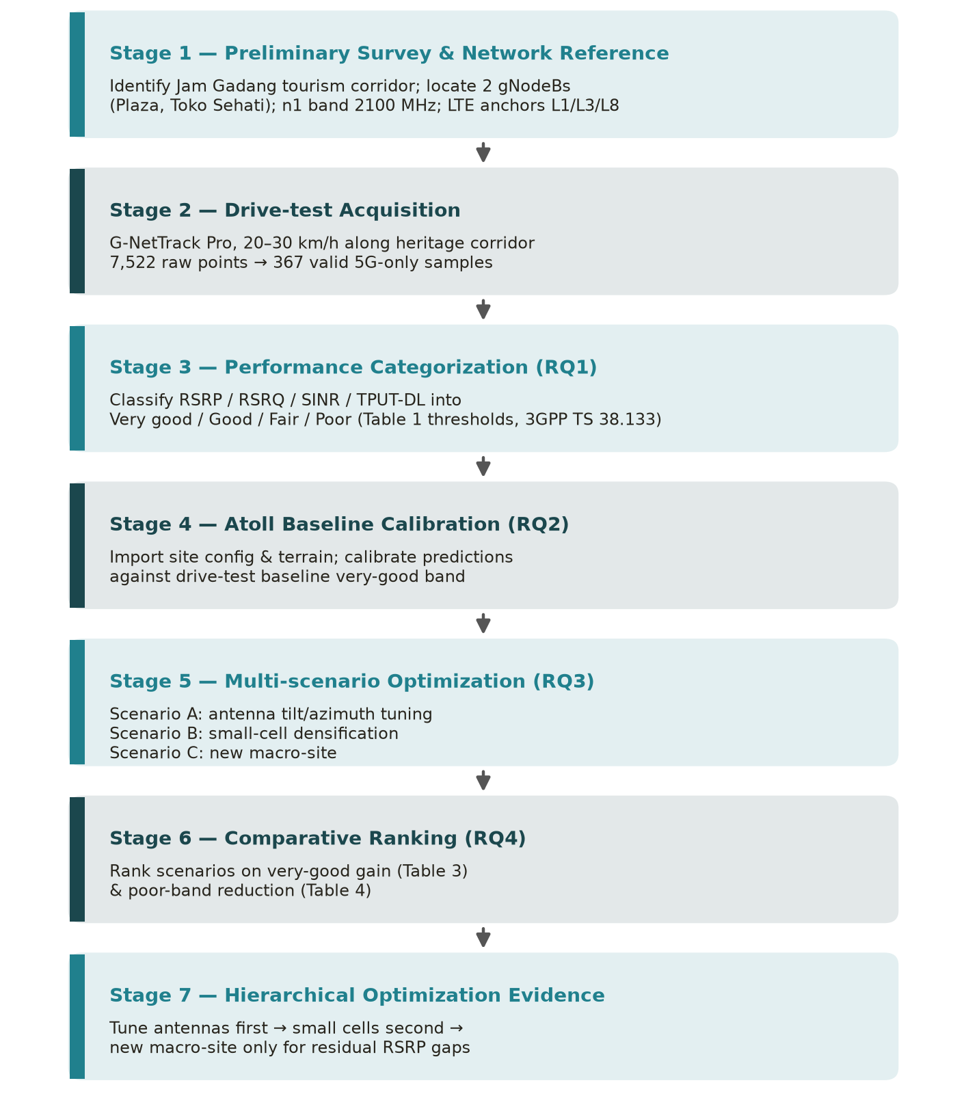
Figure 1. Research workflow: drive-test acquisition, spatial filtering, Atoll baseline calibration, multi-scenario optimization, comparative ranking, and the resulting hierarchical optimization evidence.
Table 1. Category thresholds for RSRP, RSRQ, SINR, and downlink throughput
Category | RSRP (dBm) | RSRQ (dB) | SINR (dB) | TPUT-DL (Mbps)
Very good | ≥ −85 | ≥ −10 | 10 to 30 | 14 to 20
Good | −85 to −92 | −10 to −14 | 3 to 10 | 7 to 14
Fair | −92 to −102 | −14 to −17 | 0 to 3 | 1 to 7
Poor | −102 to -120 | −17 to -25 | 0 to -20 | 0.512 to 1

- RESULTS AND DISCUSSION
This section presents empirical findings and simulation results in an integrated manner. All RSRP values are reported in dBm and TPUT-DL in Mbps, consistently using the category bands from Table 1.
3.1. Drive-test Baseline (validating Section 2.3)
Of the 7,522 raw data points, 367 valid 5G-specific samples were retained. The band category distribution is summarized in Table 2. The RSRP was predominantly in the “very good” band (97.55%). RSRQ was mostly in the “good” band (95.64%). SINR was more balanced: 46.32% “very good,” 11.44% “fair,” and 4.90% “poor.” Downlink throughput showed the weakest performance: only 0.54% in the “very good” band and 29.70% with no traffic. This confirms that throughput and SINR—not coverage—are the dominant constraints in this corridor.

Table 2. Drive-test category-band distribution (n = 367 valid 5G samples)
Category | RSRP (%) | RSRQ (%) | SINR (%) | TPUT-DL (%)
Very good | 97.55 | 1.36 | 46.32 | 0.54
Good | 2.45 | 95.64 | 37.33 | 38.42
Fair | 0.00 | 2.72 | 11.44 | 31.06
Poor | 0.00 | 0.27 | 4.90 | 0.27
No traffic / N/A | — | — | — | 29.70

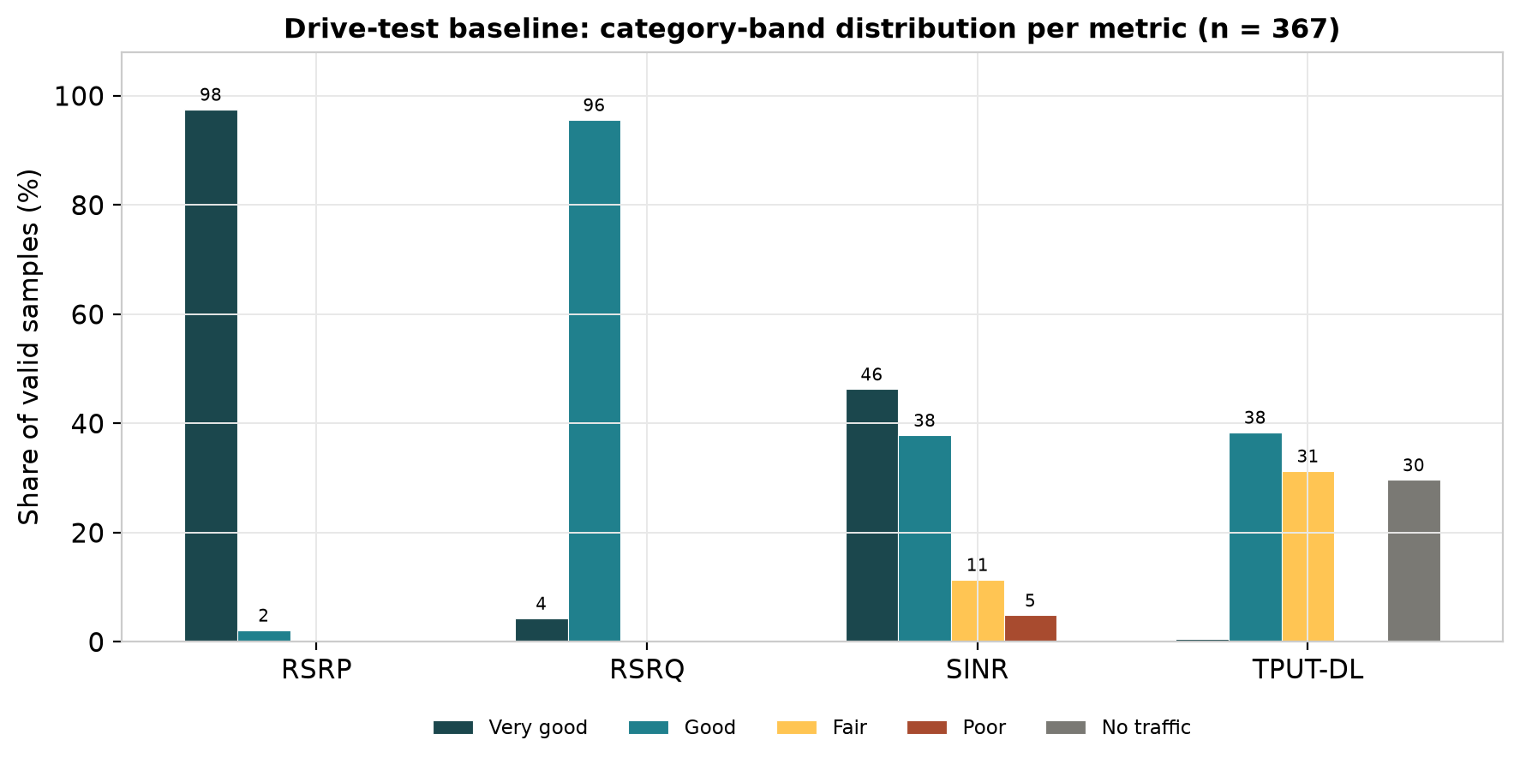
Figure 2. Drive-test baseline category-band distribution per metric (n = 367). Note: the geo-referenced RSRP/SINR/TPUT-DL heatmaps around Jam Gadang should be inserted by the author from the MapInfo project before submission.
3.2. Simulation baseline (validating Sections 2.2 and 2.4)
The baseline simulation reported 77.30% of pixels in the “very good” RSRP band, 70.55% SINR, and 93.40% TPUT-DL. The “poor” band reached 8.90% RSRP, 2.03% SINR, and 0.23% throughput. The convergence of field data and simulation results confirms the correct calibration of the propagation model, establishing a common baseline for a strictly like-for-like comparison of the three scenarios.

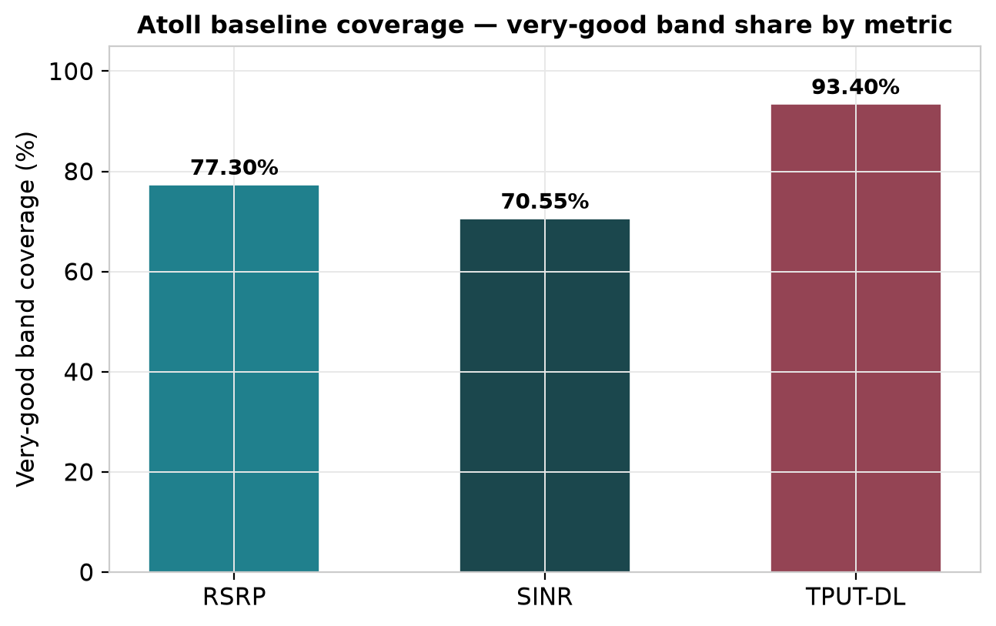
Figure 3. Atoll baseline coverage — very-good band share by metric (RSRP, SINR, TPUT-DL). Note: the actual Atoll coverage prediction maps should be inserted by the author before submission.
3.3 Optimization Scenarios (validating Section 2.4)
Each scenario was simulated using the same baseline with identical parameters. The numerical comparisons are summarized in Table 3 (very good band) and Table 4 (poor band).

3.3.1 Scenario A — Antenna Tilt and Azimuth Tuning
Scenario A improves the “very good” RSRP from 77.30% to 84.50% and the SINR from 70.55% to 77.85%, while the TPUT-DL increases from 93.40% to 96.30%. This scenario reduces the "poor" SINR from 2.03% to 0.06% without adding new hardware.
3.3.2 Scenario B — Small-Cell Densification
Scenario B resulted in the greatest increase in throughput (TPUT-DL “very good” from 93.40% to 99.00%) and SINR from 70.55% to 85.35%, but slightly reduced the “very good” RSRP to 75.04% due to energy redistribution.
3.3.3 Scenario C — New-Site Addition
Scenario C resulted in the greatest improvement in coverage: the “very good” RSRP reached 92.20% and the SINR reached 85.40%, with the “poor” RSRP band completely eliminated (0.00%).

Table 3. Comparison of Atoll baseline versus three optimization scenarios (share of samples in the very-good band)
Scenario | RSRP very good (%) | SINR very good (%) | TPUT-DL very good (%)
Baseline (existing) | 77.30 | 70.55 | 93.40
Scenario A (antenna tuning) | 84.50 | 77.85 | 96.30
Scenario B (small cells) | 75.04 | 85.35 | 99.00
Scenario C (new site) | 92.20 | 85.40 | 98.40
Table 4. Share of samples in the poor band (lower is better)
Scenario | RSRP poor (%) | SINR poor (%) | TPUT-DL poor (%)
Baseline (existing) | 8.90 | 2.03 | 0.23
Scenario A (antenna tuning) | 8.90 | 0.06 | 0.00
Scenario B (small cells) | 10.78 | 0.36 | 0.00
Scenario C (new site) | 0.00 | 0.10 | 0.00
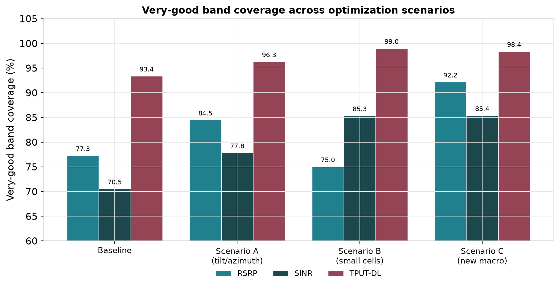
Figure 4. Very-good band coverage (RSRP, SINR, TPUT-DL) across the baseline and the three optimization scenarios (Table 3). Representative comparison; actual per-scenario Atoll coverage maps should be inserted by the author before submission.
3.4 Comparative Ranking of Optimization Strategies
Scenario C is dominant for RSRP coverage (92.20% very good, 0.00% poor). Scenario B outperforms the others for TPUT-DL (99.00% very good). Scenario A provides the lowest-cost improvement across all KPIs and nearly eliminates poor SINR (0.06%). Overall, these results reinforce the hierarchical optimization path: adjust antennas, deploy small cells at confirmed hotspots, and add macro sites only to address residual gaps. These rankings confirm the main hypothesis: the greatest benefit per cost is achieved at the lowest hierarchical level.
.
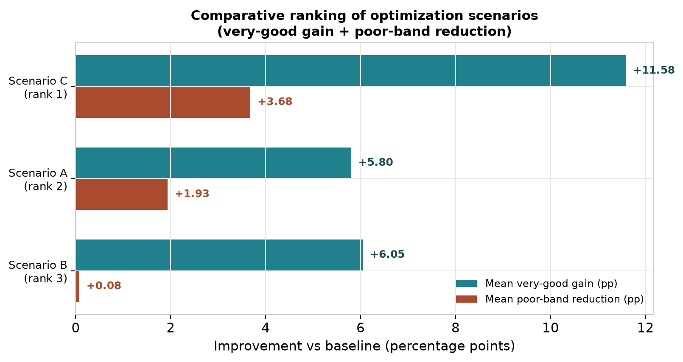
Figure 5. Comparative ranking of the three optimization scenarios by mean very-good gain and mean poor-band reduction relative to baseline (computed from Tables 3 and 4). Scenario C ranks first overall, Scenario A second, Scenario B third.
3.5 Synthesis against the performance categories and prior work (validating Sections 2.2 and 2.5)
The band-by-band interpretation of the results using the thresholds in Table 1 reconciles the two sources of evidence. Field baseline measurements and simulations agree that the RSRP is already overwhelmingly in the “very good” band, while the SINR and throughput account for the residual gap—a hallmark of legacy corridors that are coverage-limited but capacity-constrained.
The finding that zero-cost antenna tuning improves every KPI is consistent with a previous Indonesian 5G NR NSA drive test study that reported significant tuning headroom in early commercial deployments [53]. The complete elimination of the poor RSRP band in Scenario C indicates that the residual shadowing along the southern and eastern sides of Jam Gadang is geometric in nature and can be mitigated only through additional macro coverage,. A similar pattern in 5G NSA networks in urban Indonesian environments, together with throughput improvements from small-cell densification at confirmed hotspots, has likewise been reported, reinforcing the findings of Scenarios A and B,,. Subsections 3.1–3.4 collectively address the four research questions posed in the Introduction.

- CONCLUSION
This study aims to determine how multi-scenario optimization strategies—adjusting antenna tilt and azimuth, small-cell densification, and the selective addition of new sites—perform in a hilly tourist corridor with highly mobile transient users, and how the resulting trade-offs align with the principles of sustainable network planning in emerging markets. These objectives were met, as evidenced by the results reported in the Results and Discussion section.
First (RQ1), 97.55% of the RSRP samples were already in the “very good” band, confirming that coverage is not the primary limiting factor. In comparison, only 0.54% of TPUT-DL samples were “very good,” making it the dominant constraint. Second (RQ2), the simulation baseline reproduces these characteristics and confirms the correct calibration of the propagation model. Third (RQ3), zero-cost antenna tuning increases the “very good” RSRP to 84.50% and eliminates nearly all “poor” SINR (2.03% → 0.06%); small cell densification results in a “very good” TPUT-DL of 99.00%; and the addition of new sites results in a “very good” RSRP of 92.20% with the complete elimination of the “poor” band. Fourth (RQ4), the comparative rankings reinforce a clear hierarchical strategy.
These findings are fully consistent with expectations. Introduction: Cost-based and evidence-based optimization sequences align the achievement of coverage and capacity with the principle of sustainability. Practical implications: Most of the quality improvements that can be achieved in cultural heritage corridors can be realized through low-cost reconfigurations before the construction of new sites is justified.
The main limitation is the scope of a single operator and two gNodeBs, assuming static traffic. Further research is recommended for: (1) multi-operator drive tests; (2) dynamic tourism traffic models, including seasonal spikes; (3) quantitative energy consumption assessments per scenario ; and (4) validation of the hierarchical framework in other heritage tourism corridors in Indonesia and developing countries with similar topography.
ACKNOWLEDGMENTS
The authors gratefully acknowledge the support of the Department of Electrical Engineering, Politeknik Negeri Padang, for the academic environment and technical facilities that enabled this research. The authors also thank PT Telekomunikasi Selular (Telkomsel) for providing reference information on the 5G NR Non-Standalone deployment in West Sumatra, and the local stakeholders in Bukittinggi who supported the on-site drive-test campaigns around the Jam Gadang corridor.

FUNDING INFORMATION
This research did not receive any specific grant from funding agencies in the public, commercial, or not-for-profit sectors. Authors state no funding involved.

AUTHOR CONTRIBUTIONS STATEMENT
Conceptualisation: AY and FAP. Methodology: AY and MPP. Data collection: FAP. Atoll simulation: FAP and MPP. Formal analysis: AY and FAP. Writing—original draft: FAP. Writing—review and editing: AY, MPP, and AS. Supervision: AY, MPP, and AS. Project administration: AY. All authors read and approved the final manuscript.

Name of Author | C | M | So | Va | Fo | I | R | D | O | E | Vi | Su | P | Fu
Afrizal Yuhanef | v | v |  |  |  | v |  |  |  | v | v | v | v
Muhammad Putra Pamungkas |  | v | v |  |  |  |  |  |  | v | v | v
Amran Salmeno |  |  |  |  |  |  |  |  |  | v | v | v
Fikri Adi Pratama | v | v | v |  | v | v |  | v | v |  | v
C : Conceptualization  M : Methodology  So : Software  Va : Validation  Fo : Formal analysis | I : Investigation  R : Resources  D : Data Curation  O : Writing - Original Draft  E : Writing - Review & Editing | Vi : Visualization  Su : Supervision  P : Project administration  Fu : Funding acquisition

CONFLICT OF INTEREST STATEMENT
The authors declare that they have no known competing financial interests or personal relationships that could have appeared to influence the work reported in this paper. Authors state no conflict of interest.

DATA AVAILABILITY
3GPP: Third Generation Partnership Project; 5G NR: Fifth-generation New Radio; CSV: Comma-separated values; DEM: Digital elevation model; DL: Downlink; EN-DC: E-UTRAN New Radio Dual Connectivity; eNodeB: Evolved Node B; gNodeB: Next-generation Node B; KPI: Key performance indicator; LTE: Long-Term Evolution; MIMO: Multiple-input multiple-output; NSA: Non-Standalone; RSRP: Reference Signal Received Power; RSRQ: Reference Signal Received Quality; SINR: Signal-to-Interference-plus-Noise Ratio; SON: Self-organising network; TPUT-DL: Downlink throughput; UTM: Universal Transverse Mercator; WGS84: World Geodetic System 1984.

REFERENCES
[1] M. K. Banafaa et al., “A Comprehensive Survey on 5G-and-Beyond Networks With UAVs: Applications, Emerging Technologies, Regulatory Aspects, Research Trends and Challenges,” IEEE Access, vol. 12, pp. 7786–7826, 2024, doi: 10.1109/ACCESS.2023.3349208.
[2] G. Rafiq, P. Bose, and P. Orten, “5G Cellular Communication for Maritime Applications,” IEEE Access, vol. 13, pp. 109451–109472, 2025, doi: 10.1109/ACCESS.2025.3581591.
[3] H. Liu, Z. Tan, and Z. Xia, “The Coupling Coordination Relationship and Driving Factors of the Digital Economy and High-Quality Development of Rural Tourism: Insights from Chinese Experience Data,” Land, vol. 13, no. 11, p. 1734, Oct. 2024, doi: 10.3390/land13111734.
[4] Ȕzlem Tugfe Demir, E. BjɆrnson, and L. Sanguinetti, “Foundations of User-Centric Cell-Free Massive MIMO,” Found. Trends® Signal Process., vol. 14, no. 3–4, pp. 162–472, Jan. 2021, doi: 10.1561/2000000109.
[5] S. M. Hernandez and E. Bulut, “WiFi Sensing on the Edge: Signal Processing Techniques and Challenges for Real-World Systems,” IEEE Commun. Surv. Tutorials, vol. 25, no. 1, pp. 46–76, 2023, doi: 10.1109/COMST.2022.3209144.
[6] U. Ali et al., “Data-Driven Analysis of Outdoor-to-Indoor Propagation for 5G Mid-Band Operational Networks,” Futur. Internet, vol. 14, no. 8, p. 239, Aug. 2022, doi: 10.3390/fi14080239.
[7] M. Mercuri et al., “Enabling Robust Radar-Based Localization and Vital Signs Monitoring in Multipath Propagation Environments,” IEEE Trans. Biomed. Eng., vol. 68, no. 11, pp. 3228–3240, Nov. 2021, doi: 10.1109/TBME.2021.3066876.
[8] J. A. Azevedo and F. Mendonça, “A Critical Review of the Propagation Models Employed in LoRa Systems,” Sensors, vol. 24, no. 12, p. 3877, Jun. 2024, doi: 10.3390/s24123877.
[9] N. A. Alhaj et al., “Integration of Hybrid Networks, AI, Ultra Massive-MIMO, THz Frequency, and FBMC Modulation Toward 6G Requirements: A Review,” IEEE Access, vol. 12, pp. 483–513, 2024, doi: 10.1109/ACCESS.2023.3345453.
[10] T. Raj, R. Mishra, P. Kumar, and A. Kapoor, “Advances in MIMO Antenna Design for 5G: A Comprehensive Review,” Sensors, vol. 23, no. 14, p. 6329, Jul. 2023, doi: 10.3390/s23146329.
[11] P. K. Gkonis, “A Survey on Machine Learning Techniques for Massive MIMO Configurations: Application Areas, Performance Limitations and Future Challenges,” IEEE Access, vol. 11, pp. 67–88, 2023, doi: 10.1109/ACCESS.2022.3232855.
[12] A. Quirini, F. Colone, and P. Lombardo, “Outlier-Robust Three-Element Non-Uniform Linear Arrays Design Strategy for Direction of Arrival Estimation in MIMO Radar,” Sensors, vol. 25, no. 16, p. 5062, Aug. 2025, doi: 10.3390/s25165062.
[13] M. M. Ahamed and S. Faruque, “5G Network Coverage Planning and Analysis of the Deployment Challenges,” Sensors, vol. 21, no. 19, p. 6608, Oct. 2021, doi: 10.3390/s21196608.
[14] A. Souifi, Z. C. Boulanger, M. Zolghadri, M. Barkallah, and M. Haddar, “Uncertainty of key performance indicators for Industry 4.0: A methodology based on the theory of belief functions,” Comput. Ind., vol. 140, p. 103666, Sep. 2022, doi: 10.1016/j.compind.2022.103666.
[15] R.-G. Lazar, A.-V. Militaru, C.-F. Caruntu, C. Pascal, and C. Patachia-Sultanoiu, “Real-Time Data Measurement Methodology to Evaluate the 5G Network Performance Indicators,” IEEE Access, vol. 11, pp. 43909–43924, 2023, doi: 10.1109/ACCESS.2023.3271366.
[16] A. A. El-Saleh et al., “Measuring and Assessing Performance of Mobile Broadband Networks and Future 5G Trends,” Sustainability, vol. 14, no. 2, p. 829, Jan. 2022, doi: 10.3390/su14020829.
[17] A. L. Imoize, F. Udeji, J. Isabona, and C.-C. Lee, “Optimizing the Quality of Service of Mobile Broadband Networks for a Dense Urban Environment,” Futur. Internet, vol. 15, no. 5, p. 181, May 2023, doi: 10.3390/fi15050181.
[18] M. Raftopoulou et al., “Deployment and Performance Evaluation of 5G Private Networks, Enabling Use Cases in Rural Remote Areas,” IEEE Access, vol. 13, pp. 154581–154598, 2025, doi: 10.1109/ACCESS.2025.3603591.
[19] S. Ali, A. Abu-Samah, N. F. Abdullah, and N. L. Mohd Kamal, “Propagation Modeling of Unmanned Aerial Vehicle (UAV) 5G Wireless Networks in Rural Mountainous Regions Using Ray Tracing,” Drones, vol. 8, no. 7, p. 334, Jul. 2024, doi: 10.3390/drones8070334.
[20] F. Jaensch, G. Caire, and B. Demir, “Radio Map Prediction From Aerial Images and Application to Coverage Optimization,” IEEE Trans. Wirel. Commun., vol. 25, pp. 308–320, 2026, doi: 10.1109/TWC.2025.3583171.
[21] D. F. Cabrera-Castellanos, A. Aragón-Zavala, and G. Castañón-Ávila, “Closing Connectivity Gap: An Overview of Mobile Coverage Solutions for Not-Spots in Rural Zones,” Sensors, vol. 21, no. 23, p. 8037, Dec. 2021, doi: 10.3390/s21238037.
[22] B. O. Manono, B. Mwami, S. Mutavi, and F. Nzilu, “Precision Farming with Smart Sensors: Current State, Challenges and Future Outlook,” Sensors, vol. 26, no. 3, p. 882, Jan. 2026, doi: 10.3390/s26030882.
[23] L. Chen, P. Wu, K. Chitta, B. Jaeger, A. Geiger, and H. Li, “End-to-End Autonomous Driving: Challenges and Frontiers,” IEEE Trans. Pattern Anal. Mach. Intell., vol. 46, no. 12, pp. 10164–10183, Dec. 2024, doi: 10.1109/TPAMI.2024.3435937.
[24] Y. Chen, J. Li, and J. Zhang, “Digitalisation, data-driven dynamic capabilities and responsible innovation: An empirical study of SMEs in China,” Asia Pacific J. Manag., vol. 41, no. 3, pp. 1211–1251, Sep. 2024, doi: 10.1007/s10490-022-09845-6.
[25] Y. Liu and W. Song, “Navigating digital colonialism: Sovereignty models and development paths in the Global South,” Soc. Sci. Humanit. Open, vol. 13, p. 102546, Jun. 2026, doi: 10.1016/j.ssaho.2026.102546.
[26] K. Kousias et al., “Empirical performance analysis and ML-based modeling of 5G non-standalone networks,” Comput. Networks, vol. 241, p. 110207, Mar. 2024, doi: 10.1016/j.comnet.2024.110207.
[27] G. Caso et al., “The Chronicles of 5G Non-Standalone: An Empirical Analysis of Performance and Service Evolution,” IEEE Open J. Commun. Soc., vol. 5, pp. 7380–7399, 2024, doi: 10.1109/OJCOMS.2024.3499370.
[28] A. Ichimescu, N. Popescu, E. C. Popovici, and A. Toma, “Energy Efficiency for 5G and Beyond 5G: Potential, Limitations, and Future Directions,” Sensors, vol. 24, no. 22, p. 7402, Nov. 2024, doi: 10.3390/s24227402.
[29] W. Bin Abbas, Q. Z. Ahmed, F. A. Khan, N. S. Mian, P. I. Lazaridis, and P. Sureephong, “Designing Future Wireless Networks (FWN)s With Net Zero (NZ) and Zero Touch (ZT) Perspective,” IEEE Access, vol. 11, pp. 83301–83321, 2023, doi: 10.1109/ACCESS.2023.3301849.
[30] C. Sudhamani, M. Roslee, J. J. Tiang, and A. U. Rehman, “A Survey on 5G Coverage Improvement Techniques: Issues and Future Challenges,” Sensors, vol. 23, no. 4, p. 2356, Feb. 2023, doi: 10.3390/s23042356.
[31] N. S. Sauti, M. E. Daud, M. Kaamin, and S. Sahat, “GIS spatial modelling for seismic risk assessment based on exposure, resilience, and capacity indicators to seismic hazard: a case study of Pahang, Malaysia,” Geomatics, Nat. Hazards Risk, vol. 12, no. 1, pp. 1948–1972, Jan. 2021, doi: 10.1080/19475705.2021.1947903.
[32] G. Vivone, M. Dalla Mura, A. Garzelli, and F. Pacifici, “A Benchmarking Protocol for Pansharpening: Dataset, Preprocessing, and Quality Assessment,” IEEE J. Sel. Top. Appl. Earth Obs. Remote Sens., vol. 14, pp. 6102–6118, 2021, doi: 10.1109/JSTARS.2021.3086877.
[33] A. Stocco, B. Pulfer, and P. Tonella, “Mind the Gap! A Study on the Transferability of Virtual Versus Physical-World Testing of Autonomous Driving Systems,” IEEE Trans. Softw. Eng., vol. 49, no. 4, pp. 1928–1940, Apr. 2023, doi: 10.1109/TSE.2022.3202311.
[34] V. K. Dubey, “A comprehensive theoretical framework for sustainable network contracts: Contracting dimensions and Contract classification,” Heliyon, vol. 10, no. 1, p. e23622, 2024, doi: 10.1016/j.heliyon.2023.e23622.
[35] B. Madani, A. Saihi, and A. Abdelfatah, “A Systematic Review of Sustainable Supply Chain Network Design: Optimization Approaches and Research Trends,” Sustain. , vol. 16, no. 8, 2024, doi: 10.3390/su16083226.
[36] B. Hochstrasser, “Quality engineering: a new framework applied to justifying and prioritising IT investments,” Eur. J. Inf. Syst., vol. 2, no. 3, pp. 211–223, 1993, doi: 10.1057/ejis.1993.31.
[37] M. Marques and J. J. W. Powell, “Correction to: Ratings, rankings, research evaluation: how do schools of education behave strategically within stratified UK higher education? (Higher Education, (2020), 79, 5, (829-846), 10.1007/s10734-019-00440-1),” High. Educ., vol. 79, no. 5, p. 847, 2020, doi: 10.1007/s10734-019-00471-8.
[38] I. Ullah, H. El-Sayed, A. Dowhuszko, M. A. Khan, and J. Hämäläinen, “Tilt-Angle Tuning in mmWave Base Stations and Non-terrestrial IAB for Mission-Critical Communications,” IEEE Open J. Commun. Soc., no. March, 2026, doi: 10.1109/OJCOMS.2026.3681768.
[39] H. Zakeri et al., “Path Loss Model Estimation at Indoor Environment by Using Deep Neural Network and CatBoost for Wireless Application,” IEEE Access, vol. 12, no. October, pp. 159070–159085, 2024, doi: 10.1109/ACCESS.2024.3487118.
[40] Z. Xie and Y. Long, “Anti interference and fault tolerant control of UAVs integrating residual based diagnosis disturbance estimation with counter drone strategies,” Sci. Rep., vol. 16, no. 1, p. 9429, Feb. 2026, doi: 10.1038/s41598-026-37984-z.
[41] Q. Wang, P. Ma, and Y. Wang, “Sustainable Heritage Tourism in Transition: Policy, Space, and Authenticity in a UNESCO World Heritage Site,” Sustain., vol. 17, no. 21, pp. 1–25, 2025, doi: 10.3390/su17219619.
[42] A. Bellary, K. Kandasamy, and P. H. Rao, “Analysis of Wave Propagation Models with Radio Network Planning Using Dual Polarized MIMO Antenna for 5G Base Station Applications,” IEEE Access, vol. 10, pp. 29183–29193, 2022, doi: 10.1109/ACCESS.2022.3158948.
[43] B. B. Haile, E. Mutafungwa, and J. Hämäläinen, “A data-driven multiobjective optimization framework for hyperdense 5G network planning,” IEEE Access, vol. 8, pp. 169423–169443, 2020, doi: 10.1109/ACCESS.2020.3023452.
[44] M. Parvini et al., “Spectrum Sharing Schemes From 4G to 5G and Beyond: Protocol Flow, Regulation, Ecosystem, Economic,” IEEE Open J. Commun. Soc., vol. 4, no. October 2022, pp. 464–517, 2023, doi: 10.1109/OJCOMS.2023.3238569.
[45] D. Fazilova, “Uzbekistan’s coordinate system transformation from CS42 to WGS84 using distortion grid model,” Geod. Geodyn., vol. 13, no. 1, pp. 24–30, 2022, doi: 10.1016/j.geog.2021.10.001.
[46] A. Stamou et al., “Satellite Imagery for Comprehensive Urban Morphology and Surface Roughness Analysis: Leveraging GIS Tools and Google Earth Engine for Sustainable Urban Planning,” Urban Sci., vol. 9, no. 6, pp. 1–24, 2025, doi: 10.3390/urbansci9060213.
[47] B. Stroobandt et al., “Auto-induced uplink 4G and 5G RF-EMF exposure assessment using a network monitoring application in different microenvironments across seven European countries,” Environ. Res., vol. 270, no. January, 2025, doi: 10.1016/j.envres.2025.121029.
[48] J. Liu et al., “The Formation of Atolls: New Insights From Numerical Simulations,” J. Geophys. Res. Earth Surf., vol. 127, no. 8, 2022, doi: 10.1029/2022JF006812.
[49] S. Wang, Y. Lai, X. Qiu, Y. Ma, S. M. Easa, and Y. Zheng, “Implications of as-built highway horizontal curves on vehicle dynamics/kinematics characteristics under adaptive cruise control,” IET Intell. Transp. Syst., vol. 19, no. 1, pp. 1–19, 2025, doi: 10.1049/itr2.12604.
[50] M. G. Tezcan, A. Yazar, S. N. Karahan, M. S. Osmanca, and H. O. Altun, “Agentic AI-Based 5G and Beyond Radio Planning Framework,” IEEE Access, no. April, pp. 72395–72413, 2026, doi: 10.1109/ACCESS.2026.3691411.
[51] V. R. F. Guijarro, J. D. Vega Sánchez, M. C. P. Paredes, F. G. Arévalo, and D. P. M. Osorio, “Comparative Evaluation of Radio Network Planning for Different 5G-NR Channel Models on Urban Macro Environments in Quito City,” IEEE Access, vol. 12, pp. 5708–5730, 2024, doi: 10.1109/ACCESS.2024.3350182.
[52] R. K. Behara and A. K. Saha, “Comparative Performance Analysis of Deep Learning-Based Diagnostic and Predictive Models in Grid-Integrated Doubly Fed Induction Generator Wind Turbines,” Energies, vol. 18, no. 17, 2025, doi: 10.3390/en18174725.
[53] O. Putriani, S. Priyanto, I. Muthohar, and M. R. F. Amrozi, “Millimetre Wave and Sub-6 5G Readiness of Mobile Network Big Data for Public Transport Planning,” Sustain., vol. 15, no. 1, 2023, doi: 10.3390/su15010672.

BIOGRAPHIES OF AUTHORS (10 PT)
In this section, authors are required to provide their professional biography, which should include their academic background, current position, research interests, and any significant contributions to the current study. Additionally, authors should include links to their professional profiles, such as ORCID (mandatory) and, if applicable, Google Scholar, Scopus Author ID, or Web of Science (WoS) ResearcherID. This helps establish the author’s academic identity and enhances the visibility of their research.

Required Information:
- Full name: Include the author's full name as it appears in official records. If preferred, authors may use the format consistent with his/her Scopus profile.
- Email address for each author: Provide the author's professional email address to facilitate correspondence.
- Social media account:
- ORCID iD: This is a mandatory. Each author must include their ORCID iD (https://orcid.org/), which helps link his/her research output to their identity.
- Google Scholar Profile: Include the link to the author's Google Scholar profile. If the author does not have a Google Scholar profile, they may create a new one and include the link.
- Scopus Author ID: If available, include the Scopus Author ID to enhance visibility on Scopus.
- Web of Science (WoS) ResearcherID: Include the Web of Science ResearcherID. If the author does not have a WoS profile, they may create a new one and include the link.
- Brief biography: Provide a concise overview of the author's academic background, research interests, notable publications, and contributions to the current paper. This should be no longer than 150 to 200 words (9 pt).
- Professional achievements: If available, mention any important awards, recognition, or research projects the author has been involved in.
- Photo Submission: Authors must submit a clear, professional headshot (3x4 cm). The photo should be of high quality, well-lit, and not blurry. Avoid using photos that are overly casual or low resolution.
Below is an example of how to format the biography section for each author:

BIOGRAPHIES OF AUTHORS (10 PT)

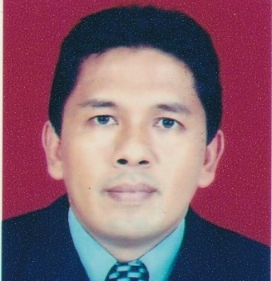 | Afrizal Yuhanef   is a lecturer at the Telecommunication Engineering Study Program, Department of Electrical Engineering, Padang State Polytechnic, Indonesia. He received his Bachelor of Engineering in Telecommunication Engineering from Institut Teknologi Sepuluh Nopember (ITS), Surabaya, in 1996. In 2006, he earned a Master’s degree in Computer Science, followed by a Doctorate in Education Science in 2017. His research interests include mobile communication systems, wireless network performance, and radio network optimization. He currently teaches courses in Connection Engineering and Traffic Engineering. Email: afrizal@pnp.ac.id
 | Muhammad Putra Pamungkas is a Lecturer at the Department of Electrical Engineering, Telecommunication Engineering Program, Politeknik Negeri Padang, Indonesia, where he has been a faculty member since 2023. He received his Undergraduate Degree in Electrical Engineering from Universitas Muhammadiyah Yogyakarta, Indonesia, in 2017. He then obtained his Master of Electrical Engineering degree in Telematics and Telecommunications Engineering from Institut Teknologi Bandung, Indonesia, in 2019. His research interests are primarily in the area of wireless communications and mobile networks, particularly radio access networks, LTE and 5G technologies, RF planning and optimization, software-defined networking (SDN), and 5G network simulation. His research focuses on the analysis, design, and optimization of next-generation communication systems to support future broadband and intelligent connectivity applications. He is actively involved in teaching and research activities related to mobile communication systems, radio access network engineering, and emerging telecommunication technologies. He can be contacted at email: mputrapamungkas@pnp.ac.id.
 | Amran Paso Salmeno graduated from the department of Electrical Engineering (Telecommunications), Andalas University, Padang, Indonesia in 2015. He received the master’s degree (cum laude) from Electrical Engineering, Institut Teknologi Bandung (ITB), Indonesia in 2023. From 2016 to 2021, he worked as Sr. Radio Access Network (RAN) Optimization Engineer at TelkomInfra, Indonesia. Subsequently, from 2023 to 2025, he worked as Sr. RAN Optimization Engineer at Huawei, Indonesia. At present, he is employed as academic staff at Politeknik Negeri Padang, Indonesia. His research interests include wireless communications, non-terrestrial networks, aerial platform communications and rural communications. He can be contacted at email: amranpaso@pnp.ac.id
 | Fikri Adi Pratama Fikri Adi Pratama is currently a fresh graduate of the Telecommunication Engineering Study Program, Department of Electrical Engineering, Padang State Polytechnic, Indonesia. He received his Bachelor of Applied Engineering (S.Tr.T.) in Telecommunication Engineering in 2026. His undergraduate research focused on the empirical analysis and coverage enhancement strategies for 5G New Radio Non-Standalone (NR NSA) networks in tourism areas using drive-test measurements and radio network simulation. His research interests include mobile communications, cellular networks, and radio network planning and optimization. He is currently preparing his first scientific publication based on his undergraduate research. Email: fikriadipratama2401@gmail.com.

